Thank you for your interest in the Arrow Evaluation program for Palo Alto Networks’ Next-Generation Firewalls. This firewall has been preconfigured to operate in your network in two different ways:

* Tap Mode – An extremely easy and non-invasive way to allow the Palo Alto Networks Next-Generation Firewall to obtain visibility into your network traffic. After ~8 days of data, a Security Lifecycle Review Report will be available which your dedicated engineer will be able to review with you.
* Layer 3 Mode – The Palo Alto Networks Next-Generation Firewall will be preconfigured to allow layer 3 traffic. Prior to shipping of the firewall, a call to review network placement to ensure the customer can plug in the firewall and hit the ground running.

Initial Setup Steps

* Connect the Palo Firewall to power and allow full bootup, ensure the following lights are illuminated green on the front of the firewall:
  + PWR
  + SYS
  + TMP
* Connect an RJ45 to the MGT port on the firewall and an existing port on a switch that will allow network access. Log into the firewall’s GUI by navigating to <https://192.168.1.1> and entering the following credentials:
* admin
* Arrow0ne

\*Note the 0 in 0ne is a zero\*

Tap Mode Instructions

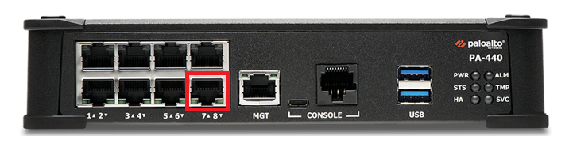

* 1. Connect Firewall e1/8 port to SPAN port on network switch
  2. Navigate to Monitor-> Traffic and ensure the firewall is capturing data. Your eval is officially in progress and allow the firewall to capture data for the next 7 days.

At the end of your evaluation, one of our team members will reach out and arrange the return of the firewall. Please kindly return all cables and the firewall to the box and we will supply a return label.

Thank you!